

PARKINGPAL UTA

DAVID VALLE | RYAN SWITZER | AESHA MOHAMED

FRED ZIRBEL | SALIM SIRAJ | ​ WALIUZ ZAMAN

INSY 4325-003 | 12/12/2023

# Introduction

Parking is one of the most challenging problems in urban areas, especially for university students who have limited time and budget. Finding a suitable parking spot can be time-consuming, costly, stressful, and can contribute to traffic congestion. Many students who have commuted to UTA may relate to this and have expressed similar claims to fellow students and university representatives. Such example can be seen in this discussion on the platform [reddit](https://www.reddit.com/r/utarlington/comments/15zfi4h/uta_parking_opening_a_can_of_worms_but/) where the UTA parking people reached out to receive constructive criticism to help students on parking concerns.

Nevertheless, one of the most liked or agreed upon statements from this post is as follows *“I don't see a reason for staff lots to be closed to students as long as they are. That was very annoying to me, showing up to school, driving past plenty of open staff lots, to a faraway lot. Then leaving in the evening, and the staff lots are still pretty much open. As well as too many unused reserved spots” which* is relatively quite an inconvenience. This statement reflects the frustration that students face when they must park far away from their classes, while there are many available spaces closer to the campus. This is considered a waste of time and energy for the students and contributes to the traffic congestion when students don’t find a spot in a lot they just entered. Nevertheless, this statement well expresses the allocation of parking resources aren’t put well in use and there must be a way to figure out how to allocate parking resources to their best use.

Another issue that students raise is that the parking system is not user-friendly, especially for new students who are not familiar with the campus. For instance, another Reddit user commented: “Being more straightforward with what kind of parking you can use/purchase, can help avoid many headaches to new students. Lastly, prices are just too high. Includes some kind of small fee… but $350 for a semester is just too much.”. This statement highlights the problem of ease of use and affordability of the parking system. Many students are confused about what kind of parking permit they need, where they can park, and how much value paying for parking actually brings them. Moreover, some students feel that the parking fees are too high, especially for those who only come to the campus less occasionally. A possible solution to this problem is to simplify the parking system and provide clear and accessible information to the students. Additionally, the parking fees could be reduced, or made more flexible, depending on the frequency and duration of the users' use.

A third issue that students mention is that the ticketing system being unfair and does not take into account the circumstances of the students. For example, one Reddit user wrote: “There should be clarity on visitor parking. As someone who’s asked guests to on-campus events, it’s difficult jumping through hoops to make sure they don’t get ticketed. We need to know when visitors can park and where”. This Statement expresses that students feel guests aren’t welcome due to the amount of ticketing and not enough knowledge of guest parking or accommodations which can be expensive for a guest as well. The whole thread of comments on this post shows much dissatisfaction students have with the ticketing system, which they perceive as a way of exploiting them rather than helping them. Some students get tickets for parking in the wrong spot, or for having a broken car, which adds to their financial burden and stress. However, the parking employees that run the reddit account stated the following.

This raises the possibility that certain students, like other visitors, may be the source of the problem. It may be a pain for the parking personnel to deal with such issues and to go through an appeal procedure, and for students having to go through this for such confusion as we can see students parking in the incorrect lot is the second top reason for ticketing. Which further gives in that the current structure isn’t ideal. There are cars that aren’t registered as well so that is a loss of value and number of parking spaces available to those who pay to park.

The students of UTA have been facing a problem of insufficient parking spaces near the campus. They have expressed their opinions and suggestions on how to solve this issue on a Reddit thread. The main idea that emerged from the discussion was to build more buildings instead of acquiring more lots for parking. This eventually would increase the number of parking spots available in a limited area and reduce the distance that students have to walk to reach their classes. However, this solution also has some drawbacks, such as the high cost of construction and maintenance of the buildings, and the possible increase in parking fees for the students. The parking committee of UTA responded to this proposal by saying that they were already planning to build another parking garage in the future, as per the campus master plan, but they also mentioned that the cost of a parking space in a garage is about $20,000, while the cost of a parking space in a surface lot is about $5,000. Students have also factored in the idea that complicates the situation is the large number of students admitted to UTA which in 2022, was about 40,000, while the number of parking spots in the lots is only 16,500. However, this number of students admitted is distributed among different locations, such as the Fort Worth station and Arlington, and different days and hours that students attend classes. Therefore, the actual demand for parking may vary depending on the time and place.

Well in this time of unprecedented campus growth, we have aimed to streamline UTA’s parking system and campus shuttle routes to help students, faculty, staff, and visitors more easily navigate the 420-acre campus. To achieve such a great level of efficiency within our campus we have come up with two main ideas involving IT to improve the overall parking experience here at UTA. This will involve implementing a parking package by Parklio which is a system that involves hardware and software to better track, manage, and maintain an efficient parking system. Along with the Parklio package we would be implementing an app that better helps students facilitate navigation and reporting. The main purpose behind Parklio is to integrate a camera and gate system that will enable the automatic recognition and control of vehicles. With that we would also be collecting and analyzing the data on parking occupancy, revenue, and user behavior to better run the operation and adjust prices and make improvements wherever needed. In this report we will describe the current design, what will be implemented, an evaluation of the smart parking system, and discuss its benefits and challenges.

## RESEARCH Questions

As we have seen the problems expressed in the Reddit thread about the poor utilization of our parking resource with restricted availability and tickets, we are in dire need right now. With over 45K students now enrolled, we must make the most of what we have. If UTA continues to admit numerous students, traffic on campus will increase, necessitating an improvement. Having already a plan to build some garages is great and all. However, it will be smart to already have a good system growing. Using ANPR smart camera (Automatic Number Plate Recognition) technology deployed within our lots would save on significant staff expenditures while providing continuous surveillance on campus. Parking officials will be able to issue citations and provide proof and will be able to ban non-paying users from our lots if they enter without paying with the use of smart gates. On the other hand, UTA will gain the opportunity to allow students to only use what they have to and not pay for a costly semester package they won’t use fully. We can expand the passes to full day cost and night discounted cost and etcetera. UTA will be able to notify students of issues in lots and when staff parking is available as well. Upgrading our smart parking system with Parklio along with UTA controlled Parkingpal app can open a whole page of possibilities and create a bigger analytical project for research and innovation at UTA.

**Current Parking System:** Other than constructing more buildings which eventually has led to a few more parking spaces, UTA has made recent efforts to improve the parking situation on campus with means that are more useful for the guests, students, and faculty. Their solution was to pay $500,000+ to Parking Logix and Modii to implement a system where users are to see how much percentage of each lot is occupied at any given time. But this came with lot of drawbacks as Parking Logix and Modii uses sensors to provide information of available parking to the user. These sensors can be easily tricked to show false data making them ineffective and not worth the investment. Below we will break down two main reasons for why this current system should be replaced:

**False Data:** As mentioned above, Parking Logix and Modii uses sensor to count vehicles as they enter and exit parking lot. This is very ineffective because if a student were to enter the lot using the exit side, the sensor would read that as if the vehicle has left the lot. Furthermore, the sensors are also sensitive to heavier vehicles. Which means if a big truck were to drive by near the sensor without ever entering the lot; there is a high chance that it would get counted entering or exiting the lot which further contributed to the inaccurate data and unhappy users.

**Data Display:** What is the point of having a system that helps to find parking if the data that the system displays is hard to interpret. Parking Logix and Modii displays the data to the user in percentage or in number format. This makes it hard for users to navigate a big parking pot or garage. An example of this is shown in the image below of an available parking sign outside the west campus garage here at UTA. As you can see, it only shows how many spaces are available and does not have any detail about which level of the garage those spaces are available on. This requires the user to drive around the entire garage to find the spots themselves. Making the data display very ineffective.

**New System Proposal:** Compared to the current system that UTA uses, the new system excels in many all the categories that the current one lacks with the help of our Parkingpal app and Parklio’s AI Camera. Our app is designed for users to navigate smoothly without creating any spot of confusion. It goes a step further by integrating with Parklio’s AI cameras to provide the users with accurate data. Below we will go into detail about why our system is better and how it can help resolve the parking problems on campus.

**Data Accuracy:** Unlike Parking Logix and Modii’s sensors, our system uses the AI smart camera to detect and provide information to the users. One smart camera can detect 200 parking spots with 99% accuracy. This accuracy rating will provide the users with reliable information that they can count on and can increase the student parking satisfaction rating.

**Data Display:** How we present the data for available parking to the users is much more effective than the current system UTA is using. Instead of giving a general available space reading, our system goes five steps forward by providing information on the exact available location. So, when it comes to a parking garage similar to the West Campus one which has multiple levels, our system would tell the users the exact space number and the level that the open spot is available on. This eliminates the need for endless driving and saves the user's tones of their precious time.

Installation Benefits: The Parklio cameras are pole mounted, meaning they are always out of the way. Where Parking Logix's sensors are mounted on the floor at the entrance and exits of every lot. Parking Logix’s bulky floor sensors can make it difficult for lower vehicles to safely enter or exit the lot as the users would always have to worry about scraping the underside of their vehicles. The pole mounted easy to install camera are out of the way making the parking lot accessible to any type of vehicles.

SENSORS VS CAMERAS  
 We already know that UTA is a commuter university, meaning that many people commute at least 20-40 minutes to get to campus. Navigating to campus and struggling to locate parking can be a frustrating endeavor and sometimes this even makes you late for your classes. Parking space detection systems are used to monitor parking availability and provide real-time parking information to drivers.

There are two main types of parking space detection systems: sensors and cameras. We recommend that UTA change from parking sensor pads to a camera detection parking management system. Currently, UTA has partnered up with Parking Logix to set up sensors in the parking lots around campus. Sensors can be a great help. Parking space detection sensors are typically installed in-ground, below each parking space. They use various technologies, such as ultrasonic, magnetic, or electromagnetic sensors, to detect the presence or absence of a vehicle. These sensors are generally inexpensive and easy to install, making them a viable option for large parking lots.

The advantages of these sensors are that they are low cost and are easy to install. They have reliable detection in most weather conditions and are durable and resistant to damage and they are also battery powered which means they are completely self-sufficient and do not require an external power source to operate. But when we look at the disadvantages of sensors it cancels out its advantages by a lot. The biggest disadvantage of sensor pads is that we need lots of them. For a parking lot that has 100 parking spots, you will need 100 sensor pads, one for each of the spots. When it comes to accurately monitoring the occupancy of outdoor parking lots, no single sensor detection mechanism can provide sufficient precision. That is why we recommend UTA switch over to the camera detection system and especially the Parklio’s detect system which we will talk about in the next section.

The Parking Detection Camera is a smart parking solution that uses cutting-edge camera technology and AI to automate parking spot surveillance. Parking detection camera systems have lots of advantages over the sensor system. Detect cameras are designed for indoor/outdoor use and are resistant to any heavy weather conditions. Parking detection cameras are mounted overhead or on poles, providing a wider field of view and the ability to monitor multiple parking spaces simultaneously. They use image processing and machine learning algorithms to analyze video footage and identify vehicles, even in low-light conditions. Wider field of view is a very big deal because instead of using 100 different sensors you can just install one camera that can detect 100 different parking spots. It will be expensive, but it provides a much better system that can end up saving you a lot in the long run and also doesn’t require as much maintenance as sensors.

Parklio features

There are a lot of parking detection systems out there that provide cameras with AI-powered automation spot detection technology but not every camera can be integrated with the existing system. This was one of the major reasons we decided to go with the devices that parklio offers. Parklio offers a lot of devices but the devices that we recommend UTA are: Parklio smart parking barrier, Parklio ANPR (Automatic Number Plate Recognition), and Parklio detect. Each of these devices provides its unique features but makes each device beneficial in its own way.

**Parklio Smart Parking Barrier:**   
The Parklio Smart Parking Barrier is a smartphone-controlled parking barrier that protects your parking space and allows key sharing among the users.  
**Features:**  
**Smartphone control:** The barrier can be opened and closed using a smartphone app.

**Key sharing:** You can share your parking space with others by giving them access to the app.

**Automatic close:** The barrier will automatically close after a vehicle leaves, providing you with a convenient and stress-free experience.

**Built-in sensor technology:** The barrier is equipped with built-in sensor technology that can detect if a car is parked over the barrier.

**Sleek design:** The barrier has a sleek and modern design that complements any parking lot.

**Parklio ANPR**  
Parklio ANPR (Automatic Number Plate Recognition) is an intelligent parking management system that utilizes computer vision and machine learning algorithms to accurately identify and recognize vehicle license plates. It leverages high-resolution cameras to capture images of vehicles entering and exiting a parking lot, extracting their license plate numbers and processing them for further analysis.

**Features:**  
**Real-time Parking Occupancy Monitoring:** Parklio ANPR continuously monitors vehicle movements within the parking lot, providing real-time insights into occupancy levels and available parking spaces. This information can be displayed on digital signage or integrated with parking guidance systems to direct drivers to open spaces.

**Access Control and Automated Ticketing:** Parklio ANPR can enforce parking rules and restrict access to authorized vehicles. By comparing captured license plates against a whitelist or blacklist, the system can grant entry to permitted vehicles or issue parking tickets to unauthorized ones.

**Parking Fee Collection:** Parklio ANPR simplifies parking fee collection by automatically identifying vehicles entering and exiting the lot. Upon exit, the system can calculate the parking duration and generate a corresponding fee, which can be charged to a linked payment account or sent as a physical invoice.

**Parking Violations Detection:** Parklio ANPR can detect and enforce parking violations, such as overstaying, illegal parking, or parking in restricted areas. By cross-referencing license plates with parking regulations, the system can identify violators and issue the appropriate tickets or penalties.

**Parking Data Analytics:** Parklio ANPR generates comprehensive parking data analytics, providing valuable insights into parking utilization patterns, vehicle types, and peak parking times. This data can be used to optimize parking management strategies, allocate resources effectively, and make data-driven decisions.

**Parklio Detect:**

Parklio Detect is an AI-powered parking monitoring system that uses a single camera to detect up to 70 parking spaces. It is accurate in all weather conditions and can identify the type, color, and license plate number of vehicles. Parklio Detect can be used with existing security or cameras that are specifically designed for parking monitoring and offers a variety of features, including real-time parking occupancy data, parking analytics, and vehicle classification.

**Features:**   
**Smart Reporting:** Provides real-time reports on parking occupancy detection, vehicle duration, peak hours, and the parking lot zones that are more occupied than others

**License Plate Recognition:** Using license plate recognition in the Detect system, you will be able to identify the vehicle's type and color and its license plate number, providing vital parking lot occupancy data.

**99% Detection Rate:** Parklio Detect offers highly accurate parking lot monitoring and vehicle identification, with a 99% accuracy rate for various types of vehicles, including cars, trucks, and motorcycles.

**Easy Remote Access:** Easily monitor your parking lot occupancy from a distance using the cloud based Parklio Parking Management System via your web browser. This allows for convenient access to parking data from any location. If you already have your own management system, you can just integrate the Parklio API.

**On-Street Detection:** With its advanced AI parking space detection, the Detect allows you to also monitor unmarked parking spaces in various residential zones and on the street. One Detect camera can replace 70 in-ground parking sensors, which makes it both cost-effective and user-friendly.

The best thing about Parklio Detect is that if you have your own camera that supports the detection feature it can easily be integrated with the Parklio Detect system. Parklio detect comes with 3 different devices. You do not need all 3 devices to make the detect system work, all you need is their detect box which has all the features of Parklio detect. Those 3 devices are:

**3 Devices:**   
**Smart Detect Camera:** Detects up to 70 parking spaces, Wall mount, Pole mount (Optional)

**Detect Box:** Parking data analysis, support up to 6 cameras, Built-in ANPR (optional), Vehicle classification (7 types)

**Display:** Informs the driver of the parking lot's current occupancy and directs him/her to available parking spaces. It is available in different sizes.

Pros & Cons of parklio system

While Parklio does sound like a system that is perfect for a parking management system it does have its pros and cons which are very important to consider before buying a product like this or changing your whole parking system because this can be an expensive pruchase and you don’t want to take any risky chances.

**Pros:**

**Easy to install and maintain:** Parklio's camera-based system is relatively straightforward to install and maintain compared to other parking management systems that require in-ground sensors or complex infrastructure.

**Vehicle tracking and monitoring:** Parklio's system can not only detect parking occupancy but also track and monitor vehicle movements within the parking area. This provides valuable insights into parking utilization patterns and driver behavior.

**Advanced analytics and data insights:** Parklio's system generates comprehensive analytics and data reports that provide valuable insights into consumer behavior, parking utilization trends, and potential areas for improvement.

**Integration with existing solutions:** Parklio's system can be integrated with existing parking management systems, access control systems, and other relevant software solutions to create a unified and streamlined parking management platform.

**Cons:**

**Higher cost compared to sensors:** Parklio's camera-based system typically has a higher initial cost compared to parking space detection sensors, which are often used in large, open parking lots.

**Power dependency:** Parklio's system requires a constant and stable source of power to operate effectively. This may pose challenges in areas with unreliable power supply.

Parklio API & sdk

While the documentation for the API and access to the SDK are closely guarded by Parklio and require signing a non-disclosure agreement to view, here are the key features for the Parklio API and SDK.

**Seamless Integration:** The Parklio API is customizable and can easily be integrated into existing websites, mobile apps, and car navigation systems. It provides the flexibility to interact with your data according to your needs, be it through automation, integration, or complete customization.

**Parking Management System:** Via a secure web-enabled Parking Management System (PMS), the ability to monitor real-time activity at all parking locations is enabled round the clock. It allows for the management of finances, employees, and customers from any location. The PMS also provides advantages for customers through real-time information, parking space reservations, a fully automated parking lot, and a seamless user experience,

**Increase Revenue:** The API provides a convenient method of payment for customers through digital payments. It also offers a look into user behavior through analytics reports, allowing for optimization, improved business practices, and reduction of costs. The reports provide revenue, cost, and occupancy metrics and are user-friendly. They also help to understand how the parking lot is performing and leverage the information to increase parking revenue.

**Efficiency and Traffic:** Maximize the efficiency of parking lots, reduce operating costs, and decrease traffic with the intelligent solutions provided by the Parklio API. The monitoring of parking space occupancy and utilization while analyzing traffic patterns is also enabled by the API.

**Customer Satisfaction:** Customer satisfaction is ensured by guaranteeing that the customers’ reserved parking space is available and waiting. With the help of the API, real-time parking information is delivered that allows customers to navigate to their parking space, shortening the time spent searching for a parking space. The Parklio barrier can be controlled as well if one is in use.

**Integration Support:** Integration time can vary depending on the complexity of the of the company’s software, but Parklio will send detailed documentation to the development team and provide regular support to ensure a smooth integration process.

**SDK Support:** By using the Software Development Kit (SDK), Parklio products can be integrated into current Android and iOS systems. Developers are equipped by the SDK with the necessary tools and resources needed to include Parklio’s features into a company’s mobile applications.

**Application Integration Steps:**

To integrate Parklio’s parking detection and ANPR capabilities into the parking application a few steps need to be followed. First, a Parklio Developer account needs to be established. After this, an integration method must be chosen. Choose the Parklio API and or SDK to create an original system and modify it as needed. API credentials with then need to be obtained, followed by implementing API calls or SDK integration. Parking data provided by the API will need to be handled. Proper testing should then be done and finally the deployment of the parking application. Parklio can be contacted for support during any of the steps mentioned if needed.

## Hypothesis

Pricing

The financial aspects of putting in place a technology-driven parking optimization solution are shown by the cost breakdown for Parklio smart barriers and parking management systems. For UTA decision-makers to make an informed decision about modernizing the current parking infrastructure, they must comprehend the subtleties of these expenses.

The range in price of individual units, which starts at a few hundred dollars and goes up to over a thousand dollars, for Parklio smart barriers is indicative of the variety of models and features the company offers. The degree of technical complexity included into each barrier directly affects the associated costs. Simple barrier control models are suited for smaller-scale installations or locations with minimal parking needs since they are priced accordingly and are intended for simpler applications.

The expenses increase when one moves into the world of parking management systems as a whole, considering both software and hardware components. The initial expenditures of a small to medium-sized deployment generally range from $10,000 to $50,000 and include a basic parking management system. Barrier control, minimum hardware, and basic software functionality are included in this entry-level investment, which makes it appropriate for locations with very simple parking requirements.

In the case of a medium- to large-scale deployment, the investment increases to include a full parking management system, with initial expenses rising to $50,000 to $200,000 or more. Advanced capabilities that are essential for managing bigger parking lots or several sites are included in this enhanced system. One of the most important features is the integration of mobile apps, which allow customers to easily interact with the parking system and obtain real-time information. Additionally, license plate recognition technology enhances security and monitoring capabilities, contributing to a more sophisticated and robust solution.

In the business space, where start-up expenses can reach $200,000 or more, the emphasis is on big installations over many parking lots. For institutions such as UTA, this degree of investment makes sense, given the scale of the campus and the variety of parking requirements of a student body that numbers more than 45,000. An enterprise-level solution has extremely complex capabilities and integrations in addition to basic functionality. Its goal is to offer a complete and state-of-the-art parking experience by managing the intricacies of a large parking infrastructure, which may cover several locations.

The expenses incurred by Parklio smart barriers and parking management systems may be understood as a calculated move to improve the parking ecosystem's effectiveness, accessibility, and overall user experience. The range of pricing points fits the varied demands of various implementation sizes, guaranteeing that UTA may select a solution that is in line with its particular goals and financial limitations. Given that UTA prides itself on being a leader in innovation, it is critical to carefully weigh these expenses when making decisions that may affect campus parking in the future.

MODel

1. A screenshot of a computer screen

   Description automatically generated
2. 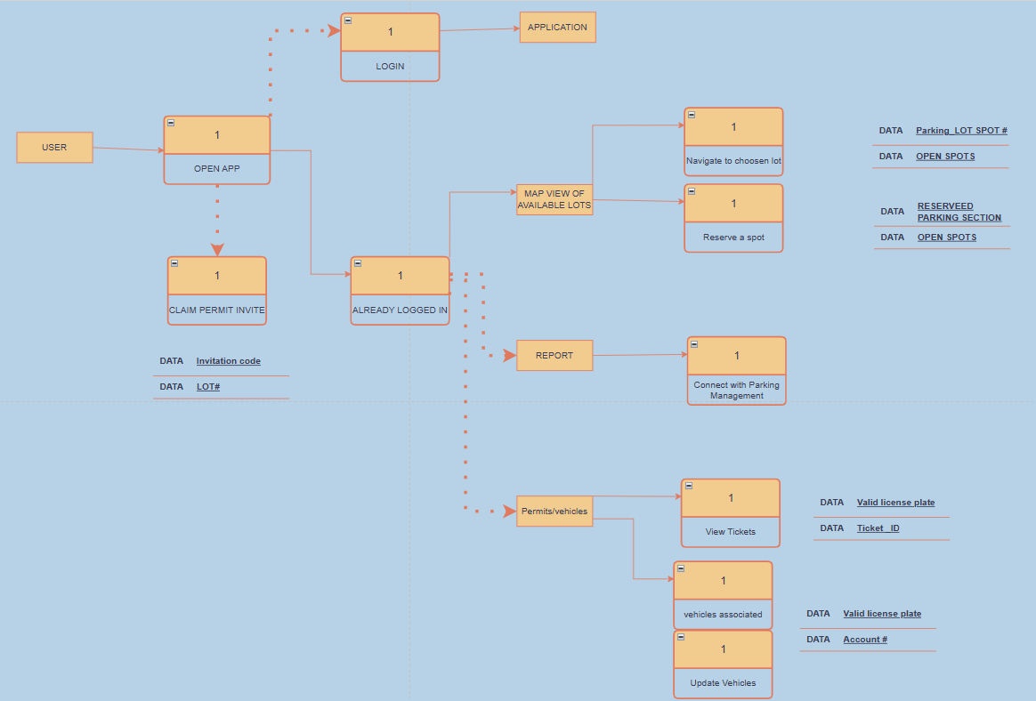
3. A screenshot of a computer

   Description automatically generated
4. A diagram of a server

   Description automatically generated

As shown in Figure 1, it is identical to the present MAV PARK login for users who sign in/up using their UTA single sign-on credentials. We would like implement this on our app as well for those who obtain credentials (Students and Staff). Upon sign-in users will remain logged in to the app who will then be greeted with the map of available lots and its details associated to their parking pass.

Also transferring from Mav Park on one of our menu pages, users will be able to review their vehicles and any associated tickets. Transferring these features into Parking Pal will help with ease of use and clarity. In addition to the menu tab there are two new features we would like to integrate with our app are Report and Reserve a Spot. Students can request help with car troubles and report suspicious activity along with getting insights on how to further improve. Now, Reserve a Spot could be experimental as lots are not at full use but with the right data we will know where to implement this feature. Nevertheless, Figure 3 represents how the Parklio system will work within our open lots alongside having a Storage system for plates that pass and aren’t supposed to be there as suggested by Parklio. Hence ticketing or upgrade pass for students. Along with Figure 3, Figure 4 depicts how these systems connect inside our systems utilizing Parklio API, with Parklio gateway provided one single gateway handling a maximum of twenty components and continually verifying status.

1. A screenshot of a computer

   Description automatically generated
2. A diagram of a system

   Description automatically generated

Now for the case of guests we would like to set a side option for users to enter. Unlike figure 2 a guest doesn’t obtain a permit invite. In most cases a guest comes here to visit students or for an event, usually in the evening when there is less traffic. In which case they would simply sign in using simple info such as email and their license plate number along with their payment. They will first be shown the parking areas they can park in and what fees they could receive. However, even before that, guests will be able to enter a lot as seen in Figure 6, Parklio will then capture that they have entered the lot.

Along with that guests will be given 10 minutes to complete the transaction, or they will be given a citation by Parking representatives. An option with the Parklio ANPR and gate system is for those who failed to pay their fees to lose access to the lots until they pay the fee thus resolving the #1 reason for ticketing in these lots.

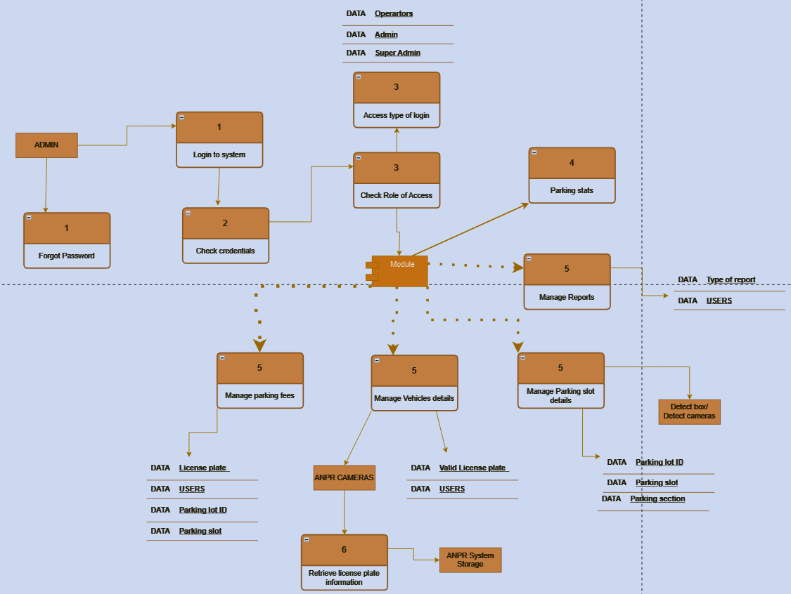

SOURCE CODE

We chose to use Swift as our main programming language for our project's iOS development because of its focus on security, performance, and developer-friendly syntax. Created by Apple, the language has an expressive and easy-to-read syntax that makes code easier to comprehend and maintain, similar to Python. The application process started off slow, but got increasingly quicker as the semester progressed. It took about three weeks to decide on what language we wanted to use, what the app should do, and how it should look. The programming itself took roughly 20 hours of work. Luckily, our team had access to powerful tools and plugins in Xcode which made the programming process much simpler. Ideally, the application would be able to implement Parklio's APIs in order to utilize their camera's recognition software, providing our app with real-time information. Overall, Swift was a great option for creating a user-friendly experience for our project due to its clean and concise syntax and readability. We have provided a glimpse into the code below.

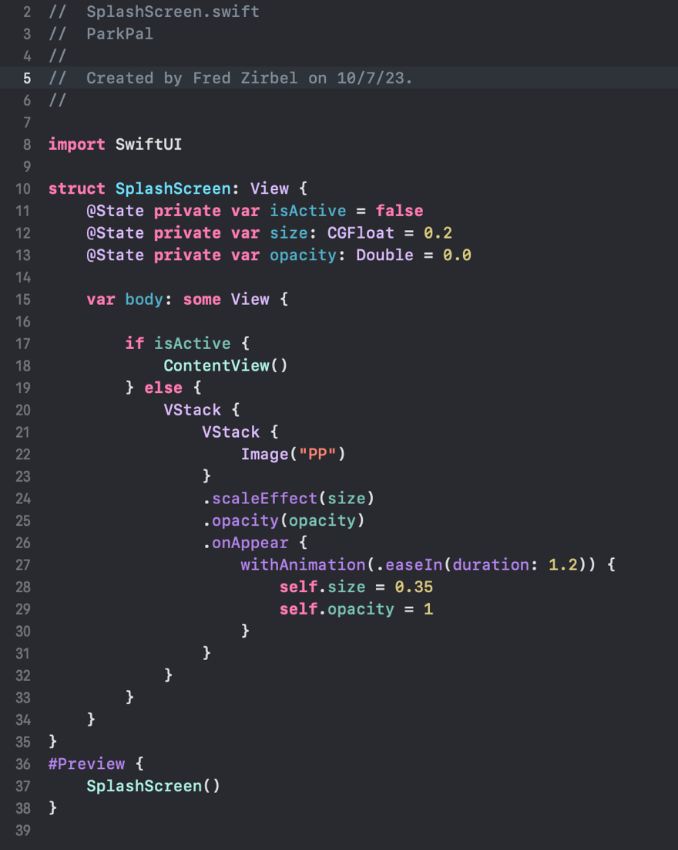

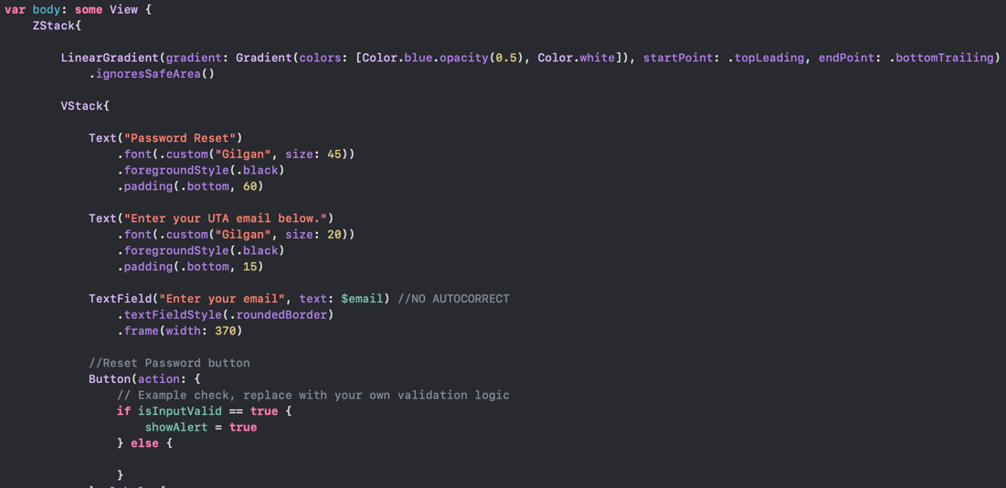

*A look into the file dedicated to the app’s login window pictured above.*

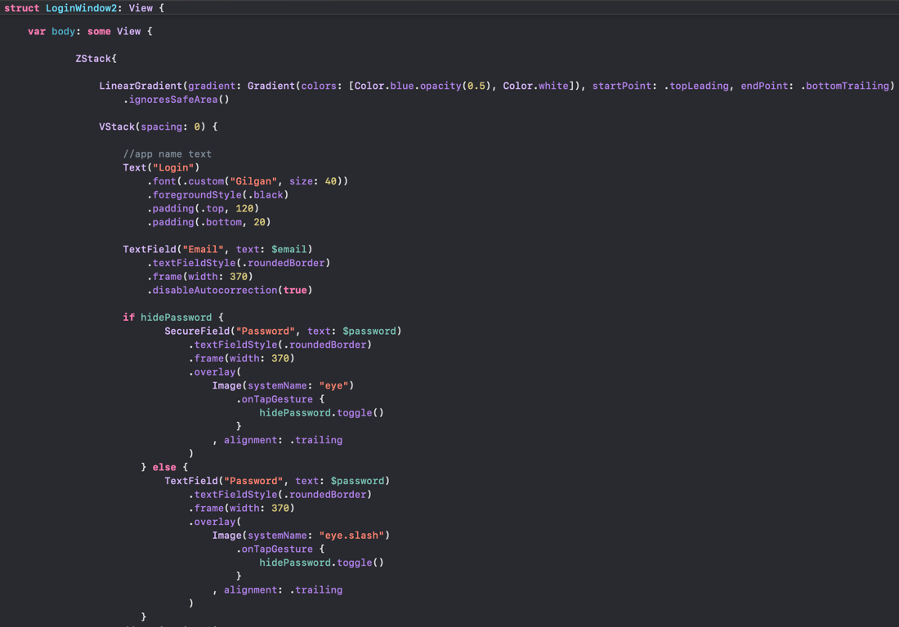

*A snippet of code showcasing the second login window.*

[GITHUB LINK TO SOURCE CODE](https://github.com/FZIRBEL/ParkingPalUTA)

## discussion

Student parking at the University of Texas at Arlington (UTA) is a major concern, especially when it comes to accessibility, cost, and convenience. The discourse on Reddit offers significant perspectives on the obstacles encountered by students and their proposed remedies. The ineffective utilization of parking resources, the lack of information that is easy to understand, the exorbitant parking costs, and the system's seeming injustice are the main causes for worry.

One of the biggest complaints is that staff spots are available and stay open while students are having trouble finding parking, which causes delays and inconveniences. Students have said that one important issue that has to be addressed is the inefficiency in the distribution of resources. The parking system's intricacy and ambiguity can add to the annoyance, especially for new students who could find it difficult to manage.

A recurring theme in the conversation is affordability, as students voice their displeasure with the expensive price of parking permits. A revision of the price system is necessary to maintain justice and accessibility given the financial strain placed on students, particularly those who visit the campus seldom.

One of the main points of dispute is the ticketing system, since students believe they are being unfairly punished. The ambiguity surrounding guest parking exacerbates the situation and highlights the need for improved knowledge and communication of the regulations. Parking staff replies point to a potential rift between the administration and students, both of whom have legitimate concerns.

The idea of building extra parking spaces to alleviate the scarcity is met with skepticism due to the associated costs and potential charge increases. The need to find a middle ground between resolving the parking problem and maintaining student affordability of tuition is also discussed.

The topics that keep coming up in the Reddit conversation highlight the necessity of a comprehensive and cutting-edge approach to solving UTA students' parking problems. The remarks about the ineffective distribution of parking spots highlight how important it is to have a strategic plan that maximizes the utilization of currently available lots. The Parklio smart parking system plan, which offers an automated and data-driven method to more effectively manage parking resources, is in line with this demand.

The issue of the parking system's unclear and unintuitive design requires a thorough fix. A consolidated platform for the provision of precise information on available parking possibilities, permit kinds, and related charges can be provided via the planned UTA-controlled parking app. Notifications in real time about parking availability and helping students get about campus effectively can also be provided by this app, which can be a useful tool for students.

As the conversation made clear, affordability is still a major problem. It's important to think about the long-term advantages of installing a smart parking system, even though the upfront fees might cause some anxiety. Over time, the institution and students may bear less financial strain as a result of cost reductions that may result from more efficient use of parking resources. As the hypothesis suggests, having pricing transparency and the ability to select parking alternatives according to personal requirements make a parking system more equitable and accessible.

The recommended smart parking solution can solve the perceived unfairness and confusion of the ticketing system. By accurately tracking parking infractions, the incorporation of ANPR cameras lowers the possibility of unfair citations. The software may also be used as a teaching tool, giving pupils precise instructions on guest parking regulations and assisting them in avoiding needless fines.

It's important to think about the costs and other options when responding to the plan to construct more parking buildings. Even while adding more garages might help with the short-term parking problem, it's important to consider the long-term sustainability and environmental impact. The suggested smart parking system provides a more adaptable and expandable option that is consistent with UTA's dedication to technological advancement.

A creative strategy is demonstrated by the plan to streamline UTA's parking system with the Parklio package and a dedicated app. By utilizing technology to improve parking management, UTA not only responds to students' immediate issues but also establishes itself as a company dedicated to offering creative solutions for its expanding community.

In summary, UTA's parking experience might be completely transformed by the suggested smart parking system, which is backed by an easy-to-use smartphone. This approach attempts to establish a more effective, transparent, and equitable parking environment by addressing the main issues brought up in the Reddit conversation. To establish a sustainable and user-centric parking system for UTA students, professors, and staff, major investments in technology and infrastructure have been made, as indicated in the hypothesis.

## Conclusion

Thoroughly analyzing the issues and worries brought up by UTA students in the Reddit conversation makes clear how urgently we need a revolutionary, cutting-edge parking remedy. A full and creative strategy is required to solve the recurring challenges that limit the university parking experience overall, as expressed by the student body with several concerns such as unjust ticketing procedures, poor resource allocation, and unintuitive technology.

First off, the students' complaints about the way parking resources are used, especially when staff spaces are closed to students, highlight how urgent it is to improve the present allocation plan. This attitude, which is expressed in phrases like "driving past plenty of open staff lots to a far away lot," emphasizes the necessity of allocating parking places in a more fair and effective manner. A technology-driven solution that can dynamically allocate resources based on real-time demand and availability is required since the existing system is unable to adjust to the changing demand for parking and the untapped availability of specific lots.

Moreover, the widespread opinion that the parking system is difficult to use, particularly for new students, highlights how important accessibility and clarity are. "Being more straightforward with what kind of parking you can use/purchase can help avoid many headaches for new students" is a statement that aligns with the demand for a clear and efficient system. The information gap may be closed and clear instructions on parking permit alternatives, locations, and associated prices can be provided by putting technology solutions into place, such as an intuitive smartphone application. The user experience may be greatly improved and the burden of navigating the complicated parking environment can be reduced by streamlining the process of receiving correct and pertinent parking information.

A modified and transparent enforcement process is even more necessary in light of the complaints made about the apparent unfairness and confusion of the ticketing system. As seen by comments like "jumping through hoops to make sure guests don't get ticketed," students' dissatisfaction with the existing system calls for a fair and open approach. Including contemporary technology, including smart gates and ANPR, or automatic number plate recognition, cameras may help with effective monitoring, wise citations, and making sure that parking regulations are understood by all parties, including guests.

Moreover, the suggestion to build new parking facilities in order to address the scarcity of parking spots calls for a careful analysis. Even when more capacity is required, it's important to take the related expenses and potential effects into account student fees.

The parking committee's explanation of the notable cost difference between surface lots and underground parking spots emphasizes the complex financial aspects of expanding the infrastructure. To meet the increasing demand for parking spots, a creative solution balancing cost-effectiveness with efficient resource usage is essential.

Our suggestion to incorporate the Parklio smart parking system along with a specific UTA-controlled parking app appears to be a solid and innovative remedy to these problems. This strategy makes use of innovations like ANPR detect cameras to offer a smooth and effective parking experience, and it is in line with the rapidly changing field of smart city technology. With automation, real-time information, and improved enforcement, the proposed system seeks to transform UTA's operating its parking resources.

Using a customized mobile app when combined with the Parklio smart barriers is a calculated technological investment that has the potential to pay off financially in the long run. The related expenses, which may run from several hundred to several thousand dollars per unit, are better seen as investments in the general improvement of the campus parking system. This technology is positioned as a change agent because of its potential for real-time monitoring, data analytics, and enhanced user communication.

With the use of our app students can bring into light more campus reports not only parking reports. Using the app can help the reporting of suspicious activity around lots where criminals tend to steal parts and or if users feel in any type of danger, they will have the option to stay in contact with emergency services around campus. Users will be able to bring up if they have car troubles and their car may be stuck there. UTA may be able to provide some services such as providing jumper cables or help with tire trouble.

Another thing of use with the app is how students will now be able to see which spaces are open to them. They can be advised as to when staff lots will be open to them and receive a notification of some sort if they choose to receive it. This will mitigate the transparency of use when using the parking at UTA and will help students recognize when staff lots are open instead of just walking by empty spaces. This will overall improve the experience for students by bringing more value and optimizing parking resources.

In summary, Parklio optimizes parking through its range of smart parking solutions, each addressing different aspects of parking management. Parklio optimizes parking by providing comprehensive solutions that enhance control, security, efficiency, and data-driven decision-making in parking management. The combination of smartphone-controlled barriers, ANPR technology, and AI-powered parking monitoring contributes to a more organized, secure, and user-friendly parking experience and when ParkingPal app is combined with Parklio's smart parking system it will provide a proactive and creative option. Through the use of this technology, ParkingPal will improve the parking experience for students at UTA, resolving the complicated challenges brought up and supporting the university's objective to improve student life on campus by encouraging innovation and providing solutions that prioritize the needs of the user.

Works Cited

“Parking Space Detection: Sensors vs Camera: Comparison Review.” *Sensors vs Camera*, Parklio, parklio.com/en/blog/parking-space-detection-sensors-vs-camera-comparison-review.

ParkingZone. “Parklio Smart Parking Barrier.” *Parklio Smart Parking Barrier*, Parking Zone, www.parkingzone.com/parklio-smart-parking-barrier.html.

“Parklio<sup>TM</sup> ANPR - Automatic Number Plate Recognition System.” *PARKING ANPR*, Parklio, parklio.com/en/parking-solutions/anpr.

“Parklio<sup>TM</sup> Detect - Ai Parking Monitoring System.” *DETECT - PARKING OCCUPANCY DETECTION*, Parklio, parklio.com/en/parking-solutions/detect.

“Smart Parking API - Optimize Your Parking Setup with Parklio API.” Parklio, parklio.com/en/parking-software/parklio-api.

“Top 10 Benefits of Smart Parking Protection and Why You Should Use It.” *Top 10 Benefits of Smart Parking Protection And Why You Should Use It*, Parklio, parklio.com/en/blog/top-10-benefits-of-smart-parking-protection-and-why-you-should-use-it.

“Top 10 Parking ANPR Systems (2023): Check Our Review Guide.”  *Top 10 Parking ANPR Systems (2023)*, Parklio, parklio.com/en/blog/top-10-parking-anpr-systems.

UTAParkingPeople. “UTA Parking: Opening a Can of Worms, But....” UTA Parking: Opening a Can of Worms, But...., Utarlington, [www.reddit.com/r/utarlington/comments/15zfi4h/uta_parking_opening_a_can_of_worms_but/](http://www.reddit.com/r/utarlington/comments/15zfi4h/uta_parking_opening_a_can_of_worms_but/).